- Tech Stack (100% Free & Open Source)
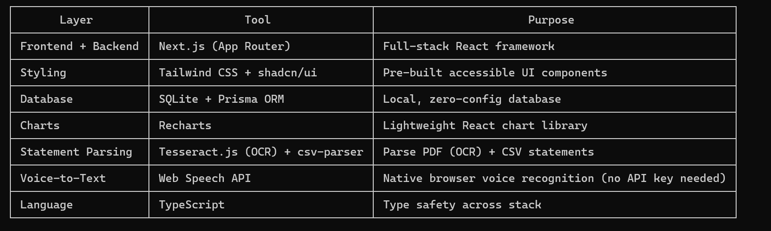

┌────────────────────┬─────────────────────────────────┬──────────────────────────────────────────────────────┐
│ Layer │ Tool │ Purpose │
├────────────────────┼─────────────────────────────────┼──────────────────────────────────────────────────────┤
│ Frontend + Backend │ Next.js (App Router) │ Full-stack React framework │
├────────────────────┼─────────────────────────────────┼──────────────────────────────────────────────────────┤
│ Styling │ Tailwind CSS + shadcn/ui │ Pre-built accessible UI components │
├────────────────────┼─────────────────────────────────┼──────────────────────────────────────────────────────┤
│ Database │ SQLite + Prisma ORM │ Local, zero-config database │
├────────────────────┼─────────────────────────────────┼──────────────────────────────────────────────────────┤
│ Charts │ Recharts │ Lightweight React chart library │
├────────────────────┼─────────────────────────────────┼──────────────────────────────────────────────────────┤
│ Statement Parsing │ Tesseract.js (OCR) + csv-parser │ Parse PDF (OCR) + CSV statements │
├────────────────────┼─────────────────────────────────┼──────────────────────────────────────────────────────┤
│ Voice-to-Text │ Web Speech API │ Native browser voice recognition (no API key needed) │
├────────────────────┼─────────────────────────────────┼──────────────────────────────────────────────────────┤
│ Language │ TypeScript │ Type safety across stack │
└────────────────────┴─────────────────────────────────┴──────────────────────────────────────────────────────┘

---
2. Modular Folder Structure

personal-finance-app/
├── src/
│ ├── app/ # Next.js App Router
│ │ ├── api/ # Backend API routes
│ │ │ ├── expenses/ # Expense CRUD endpoints
│ │ │ ├── upload/ # Statement upload & parsing
│ │ │ └── voice/ # Voice input helper (optional)
│ │ ├── dashboard/ # Analytics dashboard page
│ │ ├── expenses/ # Expense tracking page
│ │ ├── upload/ # Statement upload page
│ │ └── layout.tsx # Root layout
│ ├── components/ # Modular UI components
│ │ ├── ui/ # shadcn/ui primitives
│ │ ├── expenses/ # Expense form, list, filters
│ │ ├── dashboard/ # Charts, summary cards
│ │ ├── upload/ # File upload, parser UI
│ │ └── voice/ # Voice input component
│ ├── lib/ # Utilities & helpers
│ │ ├── db.ts # Prisma client
│ │ ├── parsers/ # CSV/PDF statement parsers
│ │ └── voice.ts # Web Speech API helper
│ ├── prisma/ # Database schema
│ │ └── schema.prisma # Expense, Category models
│ └── types/ # TypeScript interfaces
├── public/ # Static assets
└── package.json

---
3. Implementation Phases

Phase 1: Project Setup & Database

- Initialize Next.js + TypeScript + Tailwind + shadcn/ui
- Configure Prisma with SQLite
- Define data models:
- Expense: id, amount, category, date, description, paymentMethod, createdAt
- Category: id, name, color (for charts)
- Run initial database migration

Phase 2: Expense Tracking System

- Build API routes: GET/POST/PUT/DELETE /api/expenses
- Create components:
- ExpenseForm: Add/edit expenses (category dropdown, date picker)
- ExpenseList: Filterable/sortable table with pagination
- CategoryManager: Add custom categories
- Page: /expenses with form + list

Phase 3: Analytics Dashboard

- API route: GET /api/expenses/analytics (aggregate by month/category)
- Build chart components:
- MonthlySpendingChart: Line chart of spending over time
- CategoryBreakdownChart: Pie chart of spending by category
- SummaryCards: Total spent, top category, average daily spend
- Page: /dashboard with responsive grid of charts

Phase 4: Credit Card Statement Upload

- Support file types: .csv, .pdf
- Parsing logic:
- CSV: Parse with csv-parser (map columns to expense fields)
- PDF: Extract text with Tesseract.js OCR, regex-match transactions (date, amount, description)
- UI flow: Upload file → Preview parsed transactions → Confirm to bulk-add expenses
- Page: /upload with drag-and-drop zone

Phase 5: Voice-to-Text Expense Entry

- Use Web Speech API (SpeechRecognition) to capture voice input
- Parse transcribed text to extract: amount, category, description (e.g., "Spent 50 dollars on groceries" → amount: 50, category:
Groceries)
- Component: VoiceExpenseButton (microphone toggle, live transcription preview)
- Integrate into ExpenseForm

---
4. Additional Suggested Features

1. Budgeting Module: Set monthly limits per category, progress bars, overspend alerts
2. Recurring Expenses: Automate adding subscriptions (netflix, rent) on a schedule
3. Export Data: Download expenses as CSV/PDF for tax purposes
4. Dark Mode: Toggle via shadcn/ui theme provider
5. Search & Advanced Filters: Filter by date range, amount, category
6. Multi-Currency Support: Optional, for users with foreign transactions

---
5. Prerequisites

- Node.js 18+ installed
- Basic familiarity with Next.js/React (I'll handle all code)
- Modern browser (Chrome/Edge for best Web Speech API support)

---
Next step: Once you approve this plan, I'll create the project folder, initialize all dependencies, and start implementing Phase 1
(project setup + database). Let me know if you'd like to adjust any part of the stack or features!

